Sensing of NO, NO₂, and SO₂ on two dimensional WS₂ doped with Al, P, and Fe: An ab initio study
Jiamu Cao ^{a,} ^{b, c, #, *}, Jing Zhou ^{a, #, *}, Jianing Shi ª, Yufeng Zhang ^{a, b, c, *}, Junyu Chen ª, Weiqi Wang ª, and Xiaowei Liu ^{a, b, c}
ª School of Astronautics, Harbin Institute of Technology, Harbin, China
^{b} Key Laboratory of Micro-systems and Micro-Structures Manufacturing, Ministry of Education, Harbin, China
^{c} MEMS Center, Harbin Institute of Technology, Harbin, China
# The authors contributed equally to this work.
* Corresponding authors:
caojiamu@hit.edu.cn (Jiamu Cao)
daxiongmao@hit.edu.cn (Jing Zhou)
yufeng_zhang@hit.edu.cn (Yufeng Zhang)

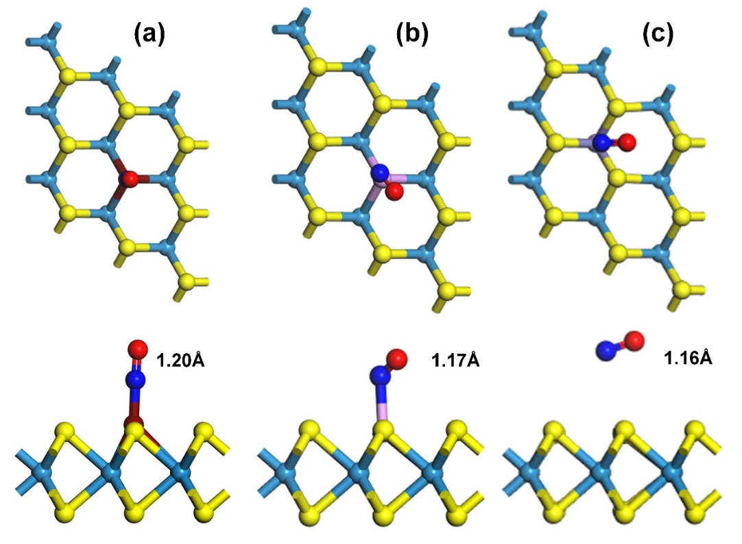
Fig.S1. The most stable adsorption model for NO adsorption on (a) Al-doped WS₂, (b) P-doped WS₂, (c) Fe-doped WS₂. Yellow, light blue, dark red, violet, purple, blue and red balls represent S, W, Al, P, Fe and O respectively, the same below. The length of the N-O bonds in these models are marked in the figures.
Fig S1 shows the most stable adsorption models of NO molecule on these three doped WS₂ (Al-, P-, Fe-doped), from left to right. The length of the N-O bond is marked in the figure. It could be seen the length has an obvious change compared with the original value of 1.16Å after adsorbed on the Al-doped WS₂.
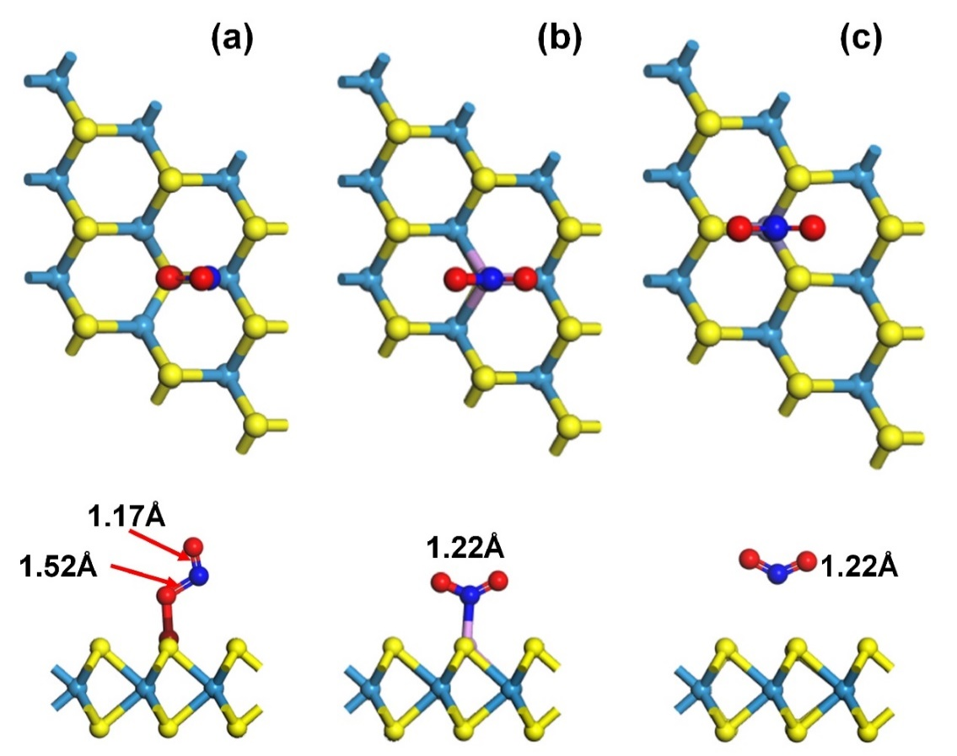
Fig.S2. The most stable adsorption model for NO₂ adsorption on (a) Al-doped WS₂, (b) P-doped WS₂, (c) Fe-doped WS₂. The length of the N-O bond after adsorption is marked in the figure.
Fig S2 shows the most stable adsorption models of NO₂ molecule on these three doped WS₂ (Al-, P-, Fe-doped), from left to right. The length of the N-O bond is marked in the figure. It could be seen the length of both N-O bonds has an obvious change compared with the original value of 1.21Å after adsorbed on the Al-doped WS₂.

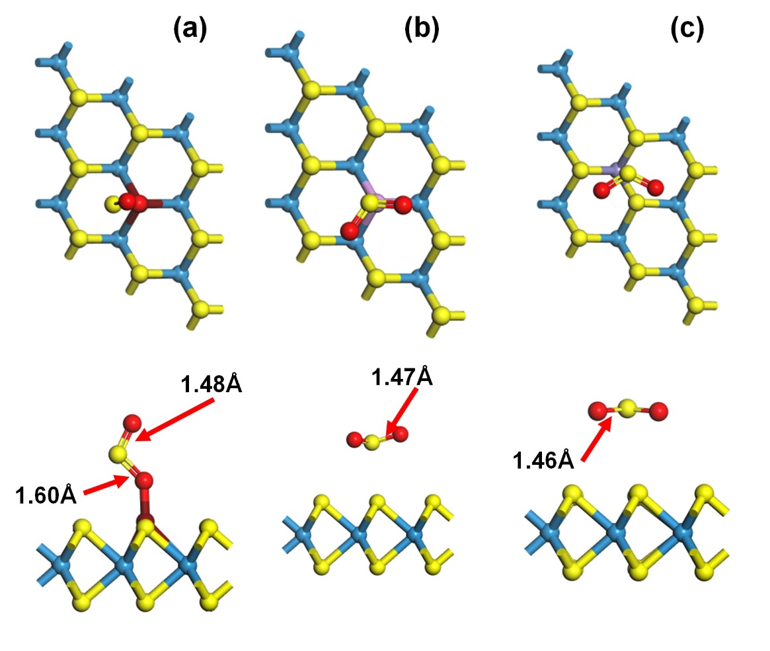
Fig.S3. The most stable adsorption model for SO₂ adsorption on (a) Al-doped WS₂, (b) P-doped WS₂, (c) Fe-doped WS₂. The length of the S-O bond after adsorption is marked in the figure.
Fig S3 shows the most stable adsorption models of SO₂ molecule on these three doped WS₂ (Al-, P-, Fe-doped), from left to right. The length of the S-O bond is marked in the figure. It could be seen the length of the S-O bond near the Al dopant has an obvious change compared with the original value of 1.46Å after adsorbed on the Al-doped WS₂.

Table.S1. The E_{ad} results of the three gases adsorbed on these pristine or doped WS₂ on the different sites.
Material | Gas | Adsorption Site | E_{ad}(eV)
Pristine WS₂ | NO | (Ⅰ) | 0.0641590
Pristine WS₂ | NO | (Ⅱ) | 0.0595004
Pristine WS₂ | NO | (Ⅲ) | 0.0501860
Pristine WS₂ | NO₂ | (Ⅰ) | 0.0050776
Pristine WS₂ | NO₂ | (Ⅱ) | 0.0019701
Pristine WS₂ | NO₂ | (Ⅲ) | -0.0011973
Pristine WS₂ | SO₂ | (Ⅰ) | -0.1197465
Pristine WS₂ | SO₂ | (Ⅱ) | -0.1663433
Pristine WS₂ | SO₂ | (Ⅲ) | -0.1396054
Fe-doped WS₂ | NO | (Ⅰ) | -0.1228867
Fe-doped WS₂ | NO | (Ⅱ) | -0.1188730
Fe-doped WS₂ | NO | (Ⅲ) | -0.1223152
Fe-doped WS₂ | NO₂ | (Ⅰ) | -0.0782110
Fe-doped WS₂ | NO₂ | (Ⅱ) | -0.0497506
Fe-doped WS₂ | NO₂ | (Ⅲ) | -0.0489696
Fe-doped WS₂ | SO₂ | (Ⅰ) | -0.1842974
Fe-doped WS₂ | SO₂ | (Ⅱ) | -0.1917669
Fe-doped WS₂ | SO₂ | (Ⅲ) | -0.1439129
P-doped WS₂ | NO | (Ⅰ) | -0.8539863
P-doped WS₂ | NO | (Ⅱ) | -0.8696056
P-doped WS₂ | NO | (Ⅲ) | -0.8717444
P-doped WS₂ | NO₂ | (Ⅰ) | -1.2736051
P-doped WS₂ | NO₂ | (Ⅱ) | -1.2733901
P-doped WS₂ | NO₂ | (Ⅲ) | -1.2653818
P-doped WS₂ | SO₂ | (Ⅰ) | -0.1732033
P-doped WS₂ | SO₂ | (Ⅱ) | -0.2947947
P-doped WS₂ | SO₂ | (Ⅲ) | -0.2870177
Al-doped WS₂ | NO | (Ⅰ) | -1.7572088
Al-doped WS₂ | NO | (Ⅱ) | -1.7581857
Al-doped WS₂ | NO | (Ⅲ) | -1.7574673
Al-doped WS₂ | NO₂ | (Ⅰ) | -3.1579401
Al-doped WS₂ | NO₂ | (Ⅱ) | -3.1585551
Al-doped WS₂ | NO₂ | (Ⅲ) | -2.9751503
Al-doped WS₂ | SO₂ | (Ⅰ) | -2.1166442

